Class demonstrations: EPS 131

Equipment
(need a separate list of equipment for each demo)
- Plastic tanks: with and without dividers
- pipe for filling and emptying tanks with water
- Foucault's pendulum: string, weight, scissors
- glass
- food coloring
- salt, measuring device for salt weight/ volume.
- Hair drier
- erasable markers (for marking water height in tanks)
- stopwatch
- calculator
- ruler
- hard boiled egg (or ping-pong ball with plastelline for changing its buoyancy
- water-volume measuring device
- scale
- spoon/ glass rod for mixing salt/ water
- ice cubes

Non Rotating experiments

- Air-pressure: insert an empty glass vertically into a water tank. How much water enters the glass as it is inserted deeper and deeper? Find an expression for the water height in the glass as function of the depth of the glass in the water tank.
- Water pressure: fill the glass with water, and take it out of the tank, with opening facing down. Suppose the glass is very long. How far can it be out of the water before the water spills out of the glass as it is removed from the tank?
- gravity waves part A: fill the square tank to some height, form a perturbation (e.g. by tilting the container) and measure with a stopper how long it takes the perturbation to return to the initial point after being reflected from the end of the container (say after two reflections). Measure the speed for 5 water heights, plot speed as function of height. Compare to the expected shallow water gravity wave speed.

- gravity waves part B: internal waves: use the divided tank, filling each half with different densities (using salt/ sugar, such that g’=g (Δρ/ρ)=g*0.01. Color the heavy fluid with food coloring, remove the divider, describe what happens.
Once the two fluids are at rest in two layers, create a perturbation and measure the speed of propagation of the resulting wave. Try this again with different thicknesses of the two fluid layers. Does the speed depend on the thicknesses?
Attempt to form a wave using a rapid and slow perturbation near the edge of the tank, which of the two is more effective in exciting a propagating wave? Why?
- Thermohaline circulation: fill the tank with water, put colored ice cubes into the container and observe the resulting circulation as the cubes melt. Compare the circulation with the cubes in the center vs side of the elongated square tank.
- Brute vassaila frequency: setup a container with two layers of fresh over colored salty water insert a hard boiled egg floating at the interface. Perturb the egg and observe and measure the frequency of its oscillations.
- Diffusion and double diffusion: insert warm/ cold & fresh/ salty water into the two sides of the divided tank. Allow to equilibrate as two layers. Is the diffusion homogeneous? Which combination of warm/ cold & fresh/ salty water leads to fingers?
- Wind stress: blow air using a hair drier over the surface of two tanks, one filled with a single layer of fluid, and one with two layers of different densities. Observe how the wind only excites the upper level in the stratified case, and the slow diffusion.
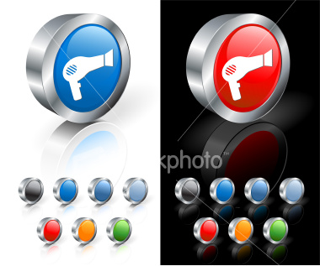
- Fuocault's pendulum: description... XX
- wave tank experiment description
- what else?

